# Experiment # 11&12

Verification of Thevenin’s and Norton’s Theorem

**Objectives:**

To verify Thevenin’s and Norton’s theorem on simulation tool PSPICE

# Apparatus:

* Computer with PSPICE software installed on it

# Procedure:

1. Open schematic program of PSpice.
2. Click on the “Get New Part” button on the toolbar.
3. Type ‘r’ in the search bar and place the eight resistors on the white sheet.
4. Type ‘vdc’ in the search bar and place it on the white sheet.
5. Type ‘gnd-earth’ and place two of them on the white sheet.
6. Now arrange these components on the white sheet according to the circuit diagram as following.
7. After arranging click on simulate button and the following results are generated.

# Norton & Thevenin Theorem:

Thevenin’s Theorem states that it is possible to simplify any linear circuit, no matter how complex, to an equivalent circuit with just a single voltage source and series resistance connected to a load. Thevenin’s Theorem is especially useful in analyzing power systems and other circuits where one particular resistor in the circuit (called the “load” resistor) is subject to change, and re-calculation of the circuit is necessary with each trial value of load resistance, to determine voltage across it and current through it.

In this lab we perform experiment to verify the Norton & Thevenin Theorem. Consider the following circuit for the verification of the theorem:

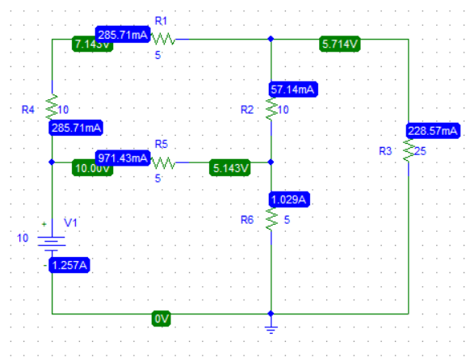

Figure 18 Circuit Diagram

In Norton & Thevenin Theorem we perform the following three steps:

1. Remove the resistor R6 and leave the circuit open across R6.
2. Remove the resistor R6 and join the wires across R6 to short the circuit.
3. Find which is given as:

Now we have to perform these steps on our circuit to find (Thevenin Resistance) and (Norton current).

# Finding Thevenin Resistance ():

To find Thevenin Resistance () we have to first find the and

# Finding :

To find we have to modify our circuit i.e remove the resistor R6 and leave the circuit open across R6:

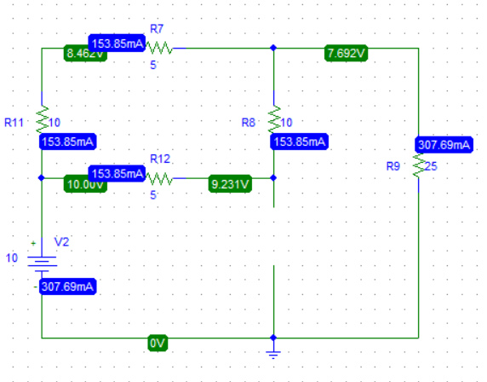

Figure 19 Modified Circuit Diagram for

Now the voltage across R6 (which is now open) is the required i.e

# Finding :

To find we have to modify our circuit i.e remove the resistor R6 and join the wires across R6 to short the circuit:

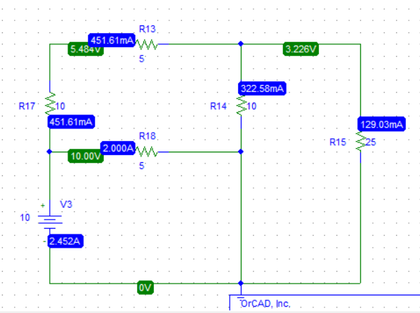

Figure 20 Modified Circuit Diagram for

Now the current across R6 (which is now removed) is the required i.e

Now we can find the Thevenin resistance using the give formula:

# Now finding the Norton current :

We can find the Norton current by using formula:

Using these values of Norton current , Thevenin Resistance () & Thevenin voltage () we can perform source Transformation and can a simplified circuit that represent the whole big circuit.

# Source Transformation:

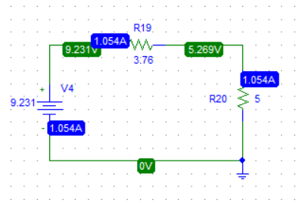

Figure 21 Source Transformation (Voltage Source)

In the above circuit voltage source has a value of that of and the resistor R20 has value of that of . This circuit now represent the whole circuit given in the Figure 1.

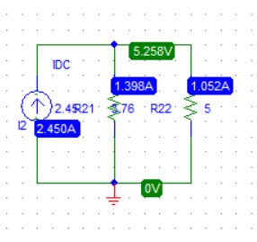

Figure 22 Source Transformation (Current Source)

In the above circuit current source has a value of that of and the resistor R21 has value of that of . This circuit now represent the whole circuit given in the Figure 1.